**Apple iTunes Music Analysis Project Report**

**Prepared By: Chama Kaushik  
Role:** Data Analyst Intern  
**Date:** August 2025

## 1. Project Overview

The Apple iTunes Music Analysis project aims to analyze sales and customer behavior data from the Apple iTunes Store to derive insights that can help the marketing, product, and operations teams make informed decisions.

**Objectives:**

1. Identify the most popular music genres and tracks.
2. Analyze sales performance by country and city.
3. Determine peak sales periods for promotional campaigns.
4. Understand customer behavior and preferences.
5. Recommend actionable strategies to improve sales and user engagement.

## 2. Data Source

The data used in this project comes from Apple iTunes and includes the following datasets:

| **Table Name** | **Description** |
| --- | --- |
| Customer | Contains customer information such as name, email, and country. |
| Invoice | Records of purchases made by customers, including invoice date and total. |
| Invoice_Line | Detailed items purchased in each invoice. |
| Track | Information about music tracks such as name, genre, and composer. |
| Genre | List of music genres. |
| Artist | Information about music artists. |
| Album | Details about albums including album name and artist. |
| Playlist | Contains playlists created in the iTunes store. |
| Playlist_track | Maps tracks to playlists. |
| Media_type | Information about media types (e.g., audio, video) of tracks. |
| Employee | Contains information about employees handling sales and support. |

**Tools Used:**  
- **SQL (MySQL)** for data extraction and preprocessing  
- **Power BI** for dashboard creation and reporting

## 3. Data Cleaning and Preprocessing

* Checked for **missing values** and inconsistencies.
* Standardized data formats for dates and currency.
* Removed duplicates in customer and invoice tables.
* Performed **joins** to combine customer, invoice, track, and genre data for analysis.

## 4. Key Analysis and Insights

### **4.1 Sales by Country**

* **Observation:** The United States had the highest revenue, followed by Canada and the UK.
* **Insight:** Focus marketing campaigns in countries with high revenue potential.

### 4.2 Top-Selling Tracks and Genres

* **Top Genre:** Rock and Pop dominated sales.
* **Top Artist:** Queen, Jimi Hendrix .
* **Insight:** Promoting popular genres and tracks can increase user engagement and revenue.

### 4.3 Sales Over Time

* **Observation:** Peak sales occur during weekends and major holidays.
* **Insight:** Schedule promotions and advertising campaigns during peak sales periods.

### 4.4 Customer Behavior

* **Observation:** Customers often buy multiple tracks together, with patterns in genre combinations.
* **Insight:** Implement recommendation systems to encourage bundle purchases.

## 5. Power BI Dashboard Design

The Power BI dashboard includes:

1. **Revenue by Country (Map Visual)**
   * Shows total sales per country.
   * Larger rectangles or bubbles indicate higher revenue.
2. **Top Tracks and Genres (Bar Chart)**
   * Highlights best-selling tracks and most popular genres.
3. **Sales Over Time (Line Chart)**
   * Displays revenue trends by day, month, and year.
4. **Customer Purchase Behavior (Tree Map)**
   * Analyzes how genres contribute to sales across different countries.
5. **KPIs (Card Visuals)**
   * Total Revenue
   * Total Number of Customers
   * Highest-Selling Genre
   * Most Popular Track

## 6. Recommendations

1. **Marketing:**
   * Target countries with high revenue potential.
   * Schedule promotions during peak periods identified in the sales analysis.
2. **Product:**
   * Focus on developing and promoting popular genres like Rock and Pop.
   * Consider bundle offers based on commonly purchased tracks.
3. **Operations:**
   * Monitor stock and licensing for high-demand tracks.
   * Optimize digital infrastructure to handle peak sales times.

## 7. Conclusion

The analysis provides actionable insights into customer behavior, track popularity, and sales trends in the Apple iTunes Store. By implementing the recommendations, the marketing, product, and operations teams can improve revenue, customer engagement, and overall business performance.

## 8. Appendix

### **8.1 Some SQL Queries Screenshots**

**Figure 1:**   
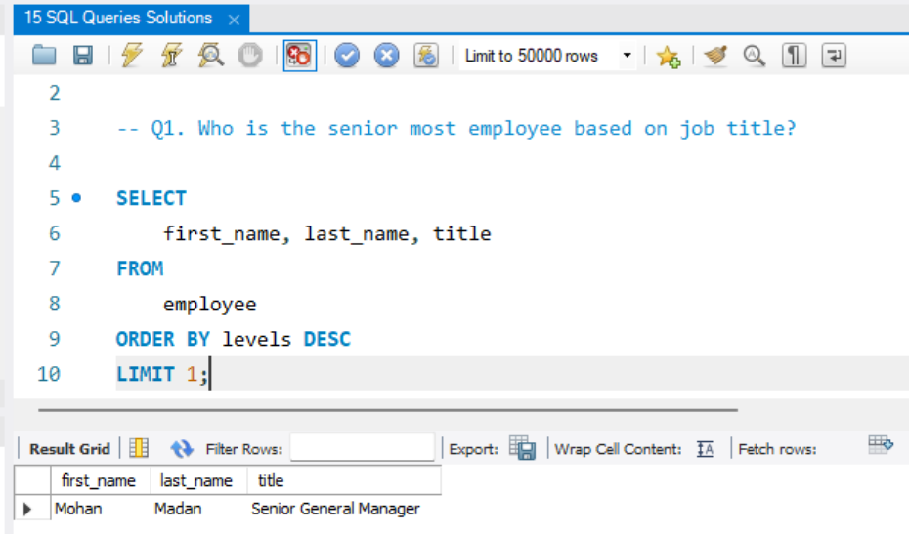

**Figure 2:**

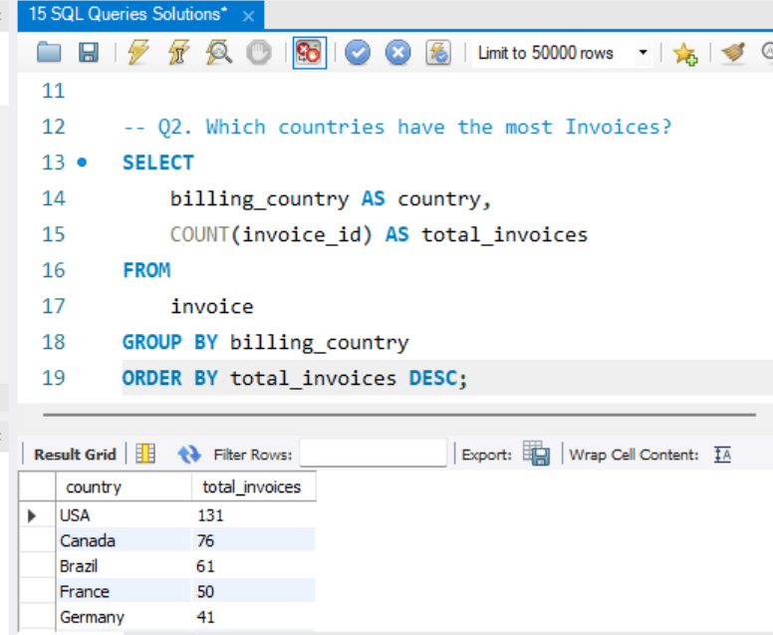

**Figure 3:**   
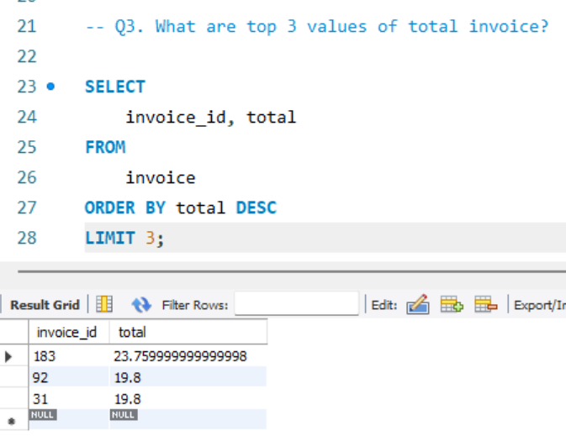

**Figure 4:**

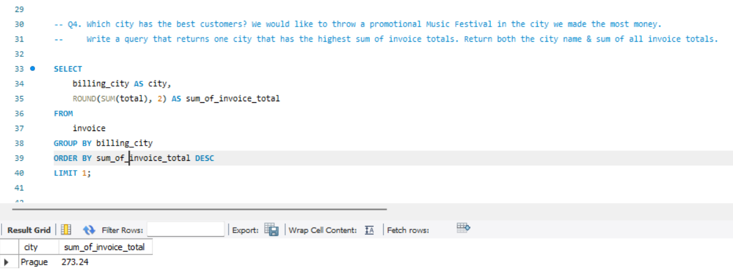

**Figure 5:**

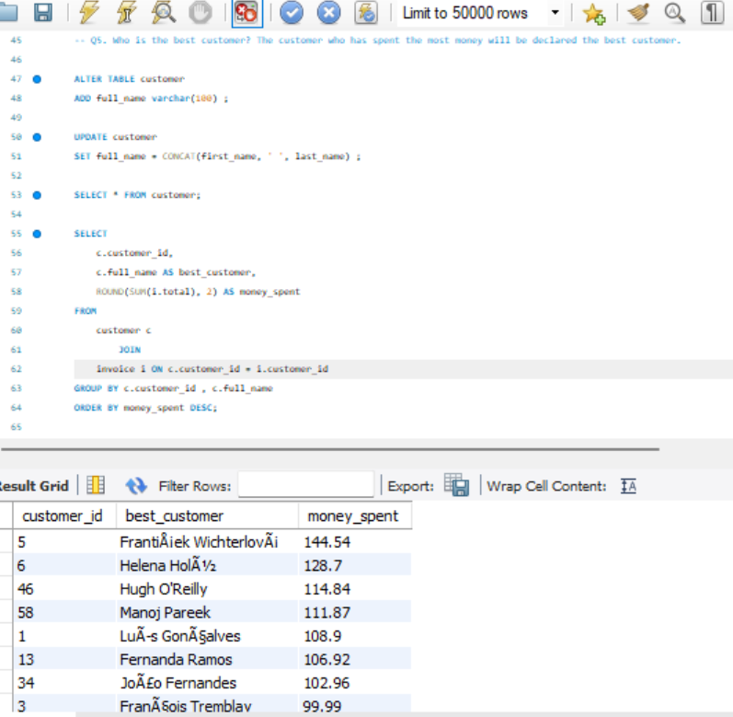

### 8.2 Power BI Dashboard Screenshots

**Figure 4:**

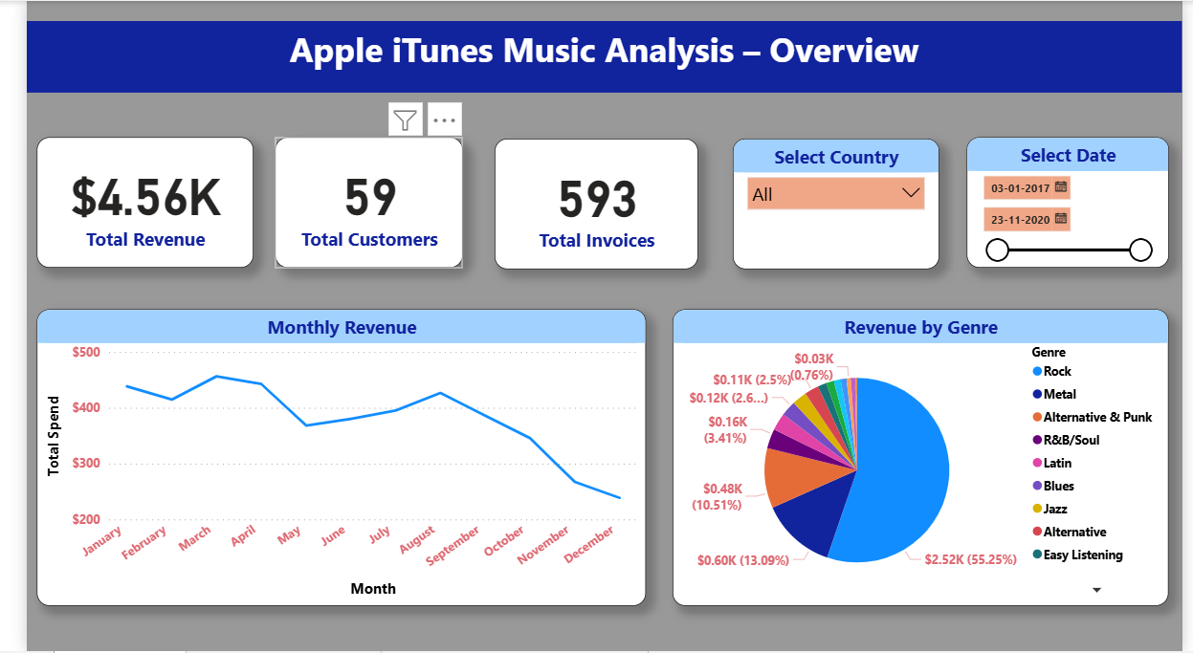

**Figure 5:**

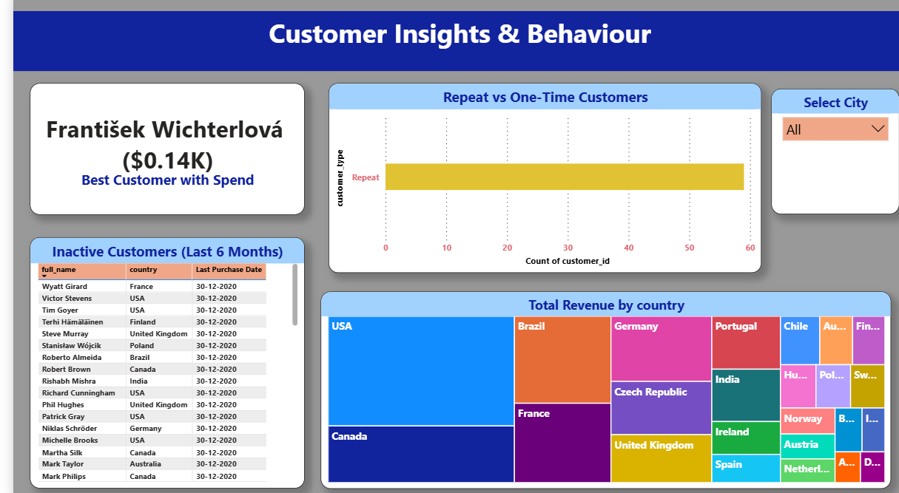

**Figure 6:**   
